|  |  |  |
| --- | --- | --- |
| **Report Component** | **Description** | **Pts. received** |
| 1. *Letter of Transmittal*   **5 points** | Formal letter to tell client what is included in the transmittal package. This item is composed after the report has been completed. |  |
| 1. *Title page* **2 points** | First sheet in report. Include title of project, date, client name, contract/reference number if applicable, statement of confidentiality if applicable. |  |
| 1. *Executive Summary*   **5 points** | This is a brief summary of the design report describing key features such as results, design overview, cost, schedule, etc. Should be no more than a couple of pages. |  |
| 1. *Acknowledgements*   **2 points** | Here is an opportunity to thank your sponsors, technical advisor, client advisor, and supporters who have provided funds, equipment, space, or advice. |  |
| 1. *Table of Contents*   **5 points** | The Table of Contents should include the major report sections and the page on which these sections begin. For longer reports there could also be a Table of Figures and/or List of Tables. |  |
| 1. *Introduction* **10 points** | Background information, historical background, motivation, etc. |  |
| 1. *Problem/Project Definition* **10 points** | Statement of the desired outcome or work product (is it a physical product, software product, process design, building/structure design, etc.), definition of the problem or problem statement, design constraints, related work, summary of literature review, summary of patent review. |  |
| 1. *Evaluation of Alternatives*   **6 points** | Screening level of analysis used to focus the design team on the alternative most likely to succeed. Alternatives not selected can be described in the appendices. |  |
| 1. *Design Approach*   **8 points** | Description of the components of the design process that the team employed in arriving at the final design. |  |
| 1. *Design Narrative, Design Verification/ Implementation, Performance Evaluation, Testing, etc.*   **22 points** | Detailed description of the design, design verification/implementation, performance evaluation, system capabilities, documentation. Discussion of testing and verification protocols and the results of testing, whether physical testing or simulation. Details of testing and other topics are typically placed in appendices. |  |
| 1. *Professional and Societal Concerns, Cost and Economic Evaluation*   **5 points** | Safety concerns and how they will be mitigated, potential environmental impacts of design, potential health impacts (both positive and negative), other societal impacts. Summary of the cost estimation and economic evaluation of the selected design including protocols applied to the economic analysis. Additional details may be appropriate in appendices. |  |
| 1. *Discussion*   **5 points** | Summary of the entire design process. |  |
| 1. *Conclusions and Recommendations*   **5 points** | Statement of the project team's conclusion of the best course of action based on the completed design process. Detailed recommendations regarding how best to execute the design. May include recommendations for additional work. |  |
| 1. *References/ Citations*   **5 points** | Documentation of the verified sources of information that provide background information on which the design is based. Should include the clients request for work, the project team’s proposal, and references to patent literature, standard handbooks, journal articles, textbooks, industry and government standards, and internet based sources. |  |
| 1. *Appendices*   **5 points** | The appendices provide an opportunity to present additional details that are not critical to the design focus. Items to include here (as appropriate) are Bill of Materials, details of modeling and simulations, details of testing protocols, detailed test results, certification of performance, details of economic analysis, alternatives evaluated but not selected, etc. |  |
| ***TOTAL*** |  |  |

Mr. Jeffery Ruocco; Mr. Jeffrey Falberg; Mr. Getro Jean-Bapiste  
Electrical & Computer Engineering Senior Design  
UNH: Tagliatela College of Engineering  
300 Boston Post Road  
West Haven, CT 06516

April 28, 2016

Bijan Karimi, Ph.D., Professor  
Electrical & Computer Engineering and Computer Science  
300 Boston Post Road; Office: B246  
West Haven, CT 06516  
203-932-7164

Dear Dr. Karimi,

Attached is the report entitled "Mobile Motion Tracking Robot Arm". This report explains in detail the work completed at University of New Haven, by the UNH students in Electrical & Computer Engineering during the fall of 2015 and spring of 2016, for the Senior Design courses required by the school.

We would much appreciate it if you read our report carefully where our report focuses on the design and construction of the robot arm, mobile platform, and programming of the Arduino and Microsoft Kinect. This is the final submitted copy of the report. Should you have any questions or comments about the report, feel free to contact us via email any time.

Sincerely,   
Jeffery Ruocco Jeffrey Falberg Getro Jean-Bapiste

**University of New Haven** **Tagliatela College of Engineering   
Department of Electrical & Computer** **Engineering and Computer Science**

Mobile Motion Tracking Robot Arm

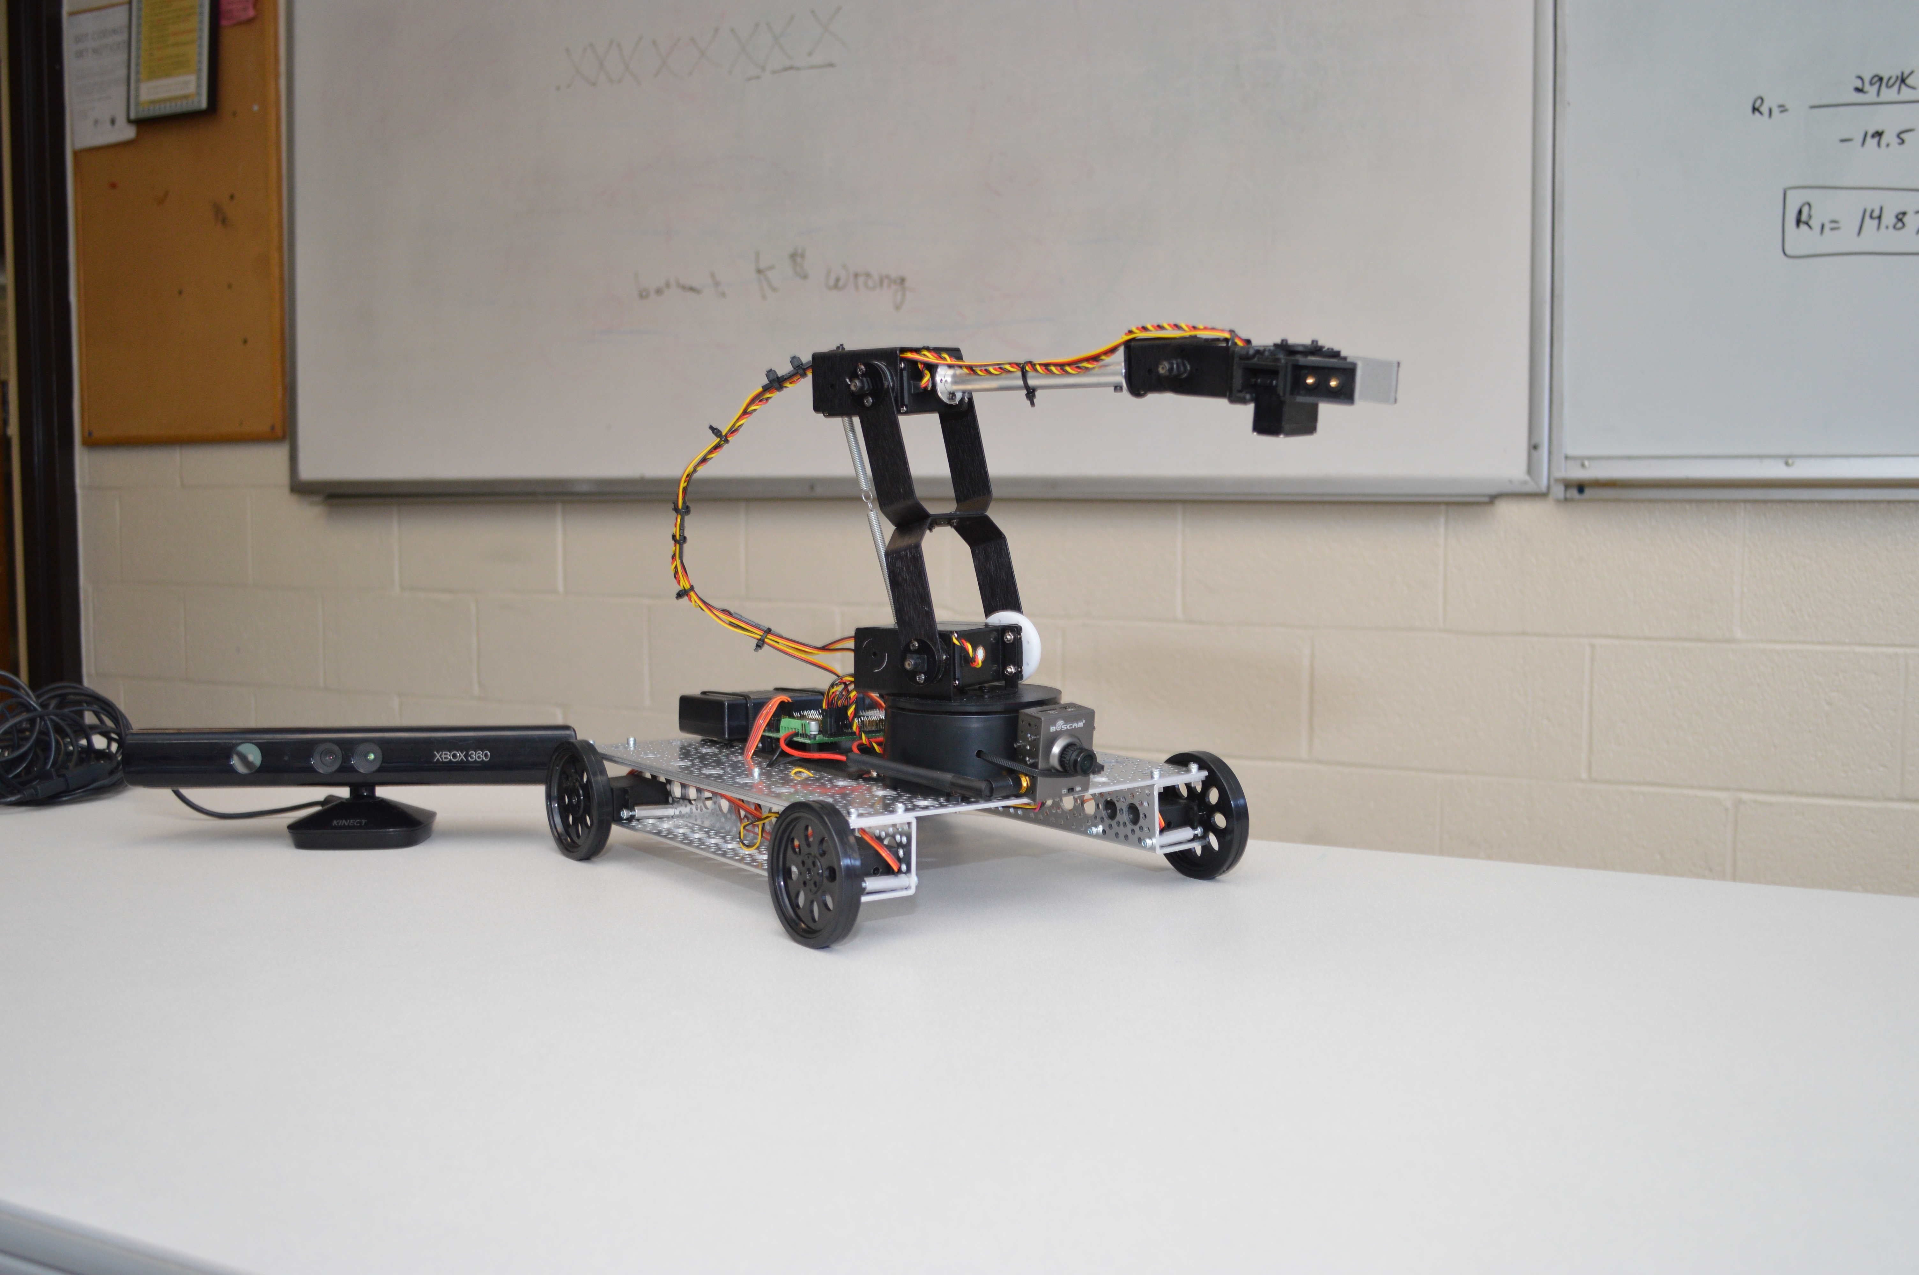

**Team Members:**

**Jeffery Ruocco, Jeffrey Falberg, Getro Jean-Baptiste**

**CMPE 4498 – Section 01**

**Professor Karimi**

**Date: April 28th, 2016**

**Group Members**

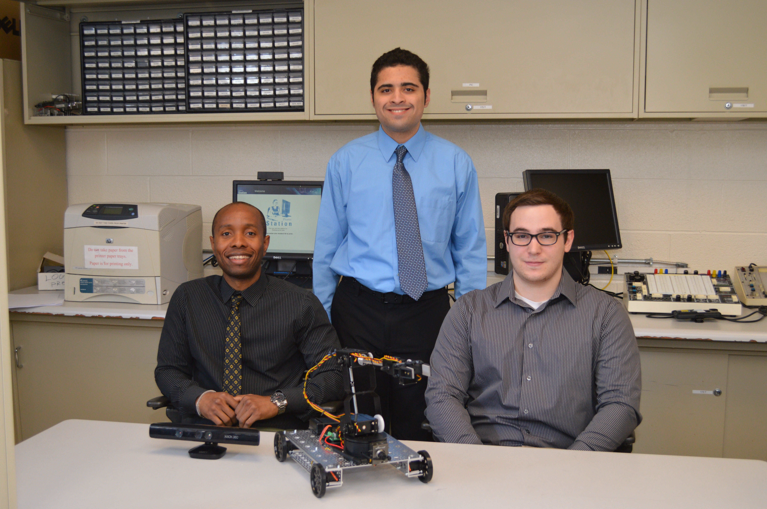

From left to right:   
**Getro Jean-Baptiste** – Responsible for constructing/designing robot arm and platform, as well as all power requirements.  
**Jeffrey Falberg** – Responsible for Arduino coding  
**Jeffery Ruocco** – Responsible for Kinect and Arduino coding

**Executive Summary**

We successfully created a mobile, motion tracking-controlled, robot arm capable of picking up small objects that are up to 100 feet from the user. Throughout the design and implementation stages of the project, our typical schedule involved meeting every Tuesday and Thursday from 3:00PM to 6:00PM, with individual work done on weekends or before meetings.

Motion tracking is handled by the Microsoft Kinect for Xbox 360. The Kinect interacts with our Kinect coordinate-mapping program written using the Kinect for Windows SDK v1.8. Coordinate information for the user’s right hand and additional commands are sent through serial to the Arduino Uno, where the coordinates are passed through inverse kinematic and linear regression calculations to be translated into servo positions. The servo positions are formed into commands and sent wirelessly

**Acknowledgments**

We would like to thank our technical advisor, Dr. Bijan Karimi, for advising us through the proposal phase of the fall semester, helping us through the design phase, and for ultimately approving our project.

We also thank Mark Morton for helping us obtain the required equipment and hardware for the project, and for his helpful suggestions.

Contents

1.0 Introduction 1

2.0 Project Definition 1

2.1 Patent Search 1

3.0 Evaluation of Alternatives 1

4.0 Design Approach 1

4.1 Robotic arm 1

4.2 Arduino 1

4.3 Kinect 1

4.4 Platform 1

5.0 Design Narrative 1

5.1 Robotic arm 1

5.2 Kinect 1

5.3 Arduino 1

5.4 Platform 1

6.0 Professional and Societal Concerns, Cost and Economic Evaluation 1

7.0 Discussion 1

8.0 Conclusion and Recommendations 1

8.1 Robotic arm 1

8.2 Kinect 1

8.3 Arduino 1

8.4 Platform 1

9.0 Keen 1

10.0 References 1

11.0 Appendices 1

# 1.0 Introduction

# 2.0 Project Definition

## 2.1 Patent Search

# 3.0 Evaluation of Alternatives

# 4.0 Design Approach

## 4.1 Robotic arm

## 4.2 Arduino

## 4.3 Kinect

## 4.4 Platform

# 5.0 Design Narrative

## 5.1 Robotic arm

## 5.2 Kinect

## 5.3 Arduino

## 5.4 Platform

# 6.0 Professional and Societal Concerns, Cost and Economic Evaluation

# 7.0 Discussion

# 8.0 Conclusion and Recommendations

## 8.1 Robotic arm

## 8.2 Kinect

## 8.3 Arduino

## 8.4 Platform

# 9.0 Keen

# 10.0 References

# 11.0 Appendices